Topic: Email Basics

When I am done this lesson, I will know:
- What email is
- How to set up an email account
- Some basic email features
- How to send a basic email

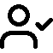Pre and Post Self-Assessment
 | Pre | Pre | Post | Post
 | Yes, I know this | No, I want to learn this | Yes, I know this | I still need more practice to learn this
I know what email is
I know how to set up an email account
I understand some basic email features
I know how to send a basic email

New Words and Terms

Email
Inbox
Outbox
Junk mail/spam
Deleted/trash
Compose
Draft
Reply
Forward
Email folders/labels
Contact
Carbon copy

What is Email?

Email is electronic mail that was developed to provide a way to send and receive messages more quickly than standard mail.
An email address has three components:
Component | Example
Email ID | john.smith
The @ symbol | @
The domain name of the email server | gmail.com

In the above example the email address would be john.smith@gmail.com
There are many different email services. Some common ones are:
- www.hotmail.com
- www. Gmail.com
- www.yahoo.ca

Although there are many different email services, they have common features like:
- Inbox
- Outbox/sent box
- Junk mail/Spam
- Deleted/Trash
- Drafts
- Compose/create new email

Note: We are going to use Gmail to learn how to use email. If you already have a Gmail email you can skip over the Setting up a Gmail Account section.
Gmail is a free email service through Google.

Setting up a Gmail Email Account
Go to www.gmail.com  Click the “Create an account” button. | 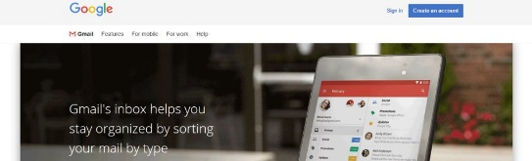
Fill in the information required.  Remember to use a strong password. | 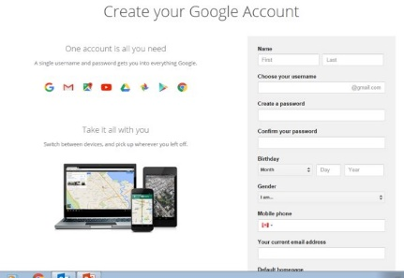
You will be asked to put in a phone number.  This will be used to verify your account. If you do not have a cell phone number, check with your instructor to see if you can use the number where you are learning.  Follow the steps as they appear. | 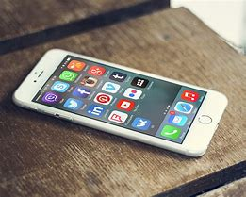
Record your new email address & password somewhere safe. | 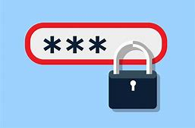

For Screen Reader Users, the steps will be similar to what is above, but here are a few tips:

- The “Create Account” button will be identified as a menu, which it is. Press enter to open the menu. Yu will be asked whether you want to make an email account for yourself, or for a business. You can arrow up, be careful not to arrow out of this menu, as it will close if you do. Just press “Enter” on the button to create account and it will expand again.
- You can navigate the various screens of the account creation process using the techniques taught in the Forms Module. Tabbing and SHIFT + Tabbing through the fields, typing when requested, and pressing ALT + down arrow to open any list or combo boxes.

- You may need a cell phone to verify yourself with Google. This author didn't, but that may be because a Gmail account already existed in this author’s name.

- There will come a point where you must fill out what is called a Captcha, which is supposed to prevent spammers from creating accounts. For someone who can see, there is a bunch of jumbled letters in a picture that need to be entered in a text box. An audio version of the Captcha is also available. You should be able to locate this by tabbing and or using the arrow keys. You can activate the features of this audio Captcha by pressing space and enter. You will need to have a good ear though, as the audio will be muffled. It may not hurt to ask the instructor for some assistance if you get stuck here.

- Once the account is created, this author very highly recommends that the HTML view is used, as it provides a much more accessible interface for screen reader users. A link to the HTML view should be one of the first links at the top of the window, you can locate it using your arrow keys, and activate it with space or enter as usual.

Using Your Email Account

When you log into a Gmail account you will be taken to your ”inbox”
The “inbox” is the folder where unread and read emails are stored that you have not deleted.
Emails that have not been read will usually stand out somehow. They might be bolded or be a different color.
Screen reader users will find that the list of messages in the inbox will be presented as a table view. Every screen reader has a set of commands for working with tables. Jaws and / or NVDA users can use CTRL + ALT + left and right arrows to move across the columns, and CTRL + ALT + up and down arrows to move up and down the rows.

Email Folders
The most common folders are:
- Sent
- Spam / junk
- Trash
- Drafts
Sent: After you have sent an email, it will automatically be stored in the “Sent” folder.

Spam/Junk: Emails such as advertisements that your email account has blocked or
filtered are stored here.
Trash: Emails that you have deleted are stored here.
Drafts: Emails that you have started or are working on are stored here.
Screen reader users will find these as links under the level 2 heading of folders. You can open these folders with space or enter, their associated messages will be presented in a table, just like the inbox.

Email – Create a Label

You can create your own folders to organize emails you want to keep. In Gmail, they are called “Labels”. You will see a folder at the top of the page. If you click on it, you will see this drop-down. This allows you to create a new label.
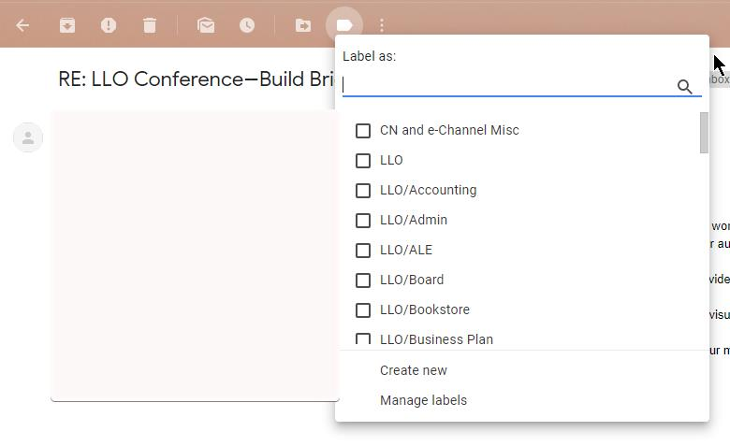
When you want to add an email to a label, open the email from your inbox. Click on the icon at the top that looks like a folder with an arrow on it. You will see this drop-down menu. From here you can move the email into the folder or label you want.
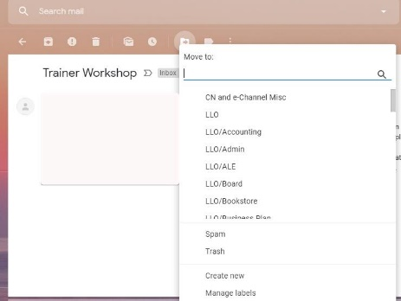
Labels with screen readers is a bit different.
- You will find Labels under a heading of their own. At the end of the list of labels, you will find a link that says: “Edit Labels.”

- Once you have activated this, navigate with your arrow keys, or press T to jump to the table full of labels. This table will be very short, as you have not made any labels yet.
- On the bottommost row, you will find an edit field where you can add a new label. Make sure you are in the mode of your screen reader which allows you to type, type in your text, and then press the “Add” button with space or enter to make your label.

- Also, in the table of labels, you can remove ones you no longer wish to use with the link labeled “remove”.

- To add a message to your new labeled folder, go back to your inbox, find a message in the table of messages, activate its checkbox in the leftmost column, and then either navigate back up the message list, or press SHIFT + C to navigate to the more actions combo box. Open the combo box with ALT + DOWN ARROW, locate the label in the box with the arrow keys, and finally press enter to move the message or messages to that label. It is a lot easier than it sounds, although it may take some practice.

Email- Replying

When you open an email and read it, you have the option to:
- Reply
- Reply All
- Forward
- Delete
Reply: Send a message back to the person who sent you the current email.
Reply All: If the email was sent to yourself AND others, when you reply to all, everyone who received the original email, will also receive your reply.
Forward: The forwarding feature can be used to send an email to someone else that was originally sent you.
Delete: This will move the email to the deleted folder. You can still see the email in the Folder: If you delete an email by accident, you can move it back to the inbox.

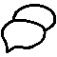Discussion Question
- When would you forward email?
For screen reader users, all of the replying and forwarding features are located at the top of a message when you open it. They are links, and your screen reader may identify shortcut keys for these and other features.

Contacts/Address Book

Most email accounts will let you save other people’s email address in a “Contacts Folder” or “Address Book”.
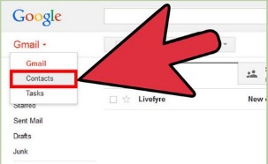

Within your address book or contacts folder there should be a link called “New” or “Add” or “Add New Contact”. You can click on this to add a new email address.
Screen reader users can find the “contacts” feature just under the folder list. It is also identified as a link.

Creating and Sending Email

To create a new email, you will need to click on a link labeled “New”, “Compose” or Create”.
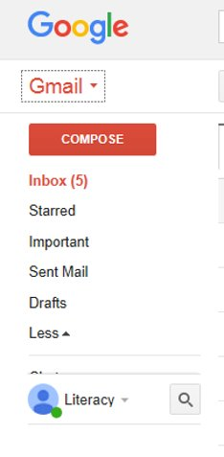
You will now have a blank mail on your screen.
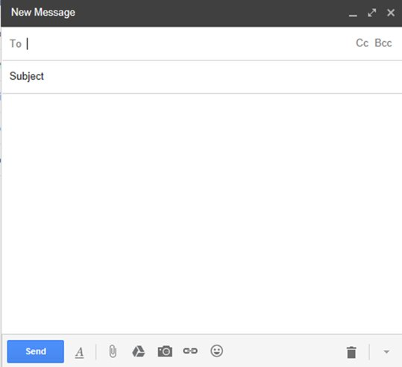
To: this is where you will need to type the person’s email address
- Some email accounts will allow you to start typing the address or person’s name and the remainder pops up for you
- Others you will need to use your Contacts folder or Address Book to find the address
- You can enter more than one person’s name
CC: Carbon Copy
- Used when you want a copy of your email sent to another recipient as well
- Used in the workplace frequently
BCC: Blank Carbon Copy
- A copy of an email message sent to a recipient whose email address does not appear in the message
- The person in the “To” box will not know that the person in the “Bcc” box is also getting the email

Subject: Gives the recipient an idea of what your email is about
- Only needs to be a few words
- Example: Kitchen Helper Position

Body: This is where you type your email message.
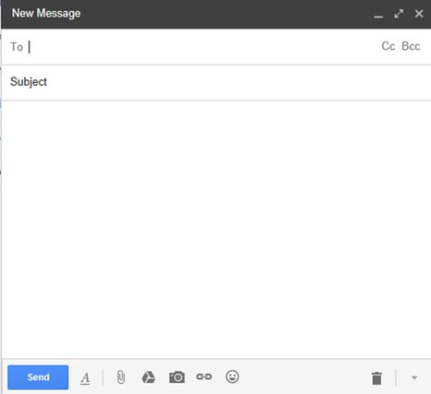

You can use features similar to ones in Microsoft Word, such as bold, underline, font size, etc. by clicking on the A at the bottom of the New Message box.
Once you have written your email, and you are happy with it, you can click “Send”.
Screen reader users will be able to send an email by doing the following.
- Find the compose option as one of the links nearer the top of the screen.

- Once you activate the compose link, you will immediately be placed in the form for creating a new email, which can be navigated like any standard form.

- If you start typing a contacts name for someone who you have either added to your contact list, or who you have emailed before, you will need to tab away and shift plus tab back to see that person’s email address added.

- The editing features to not appear to be available in the more accessible HTML interface, which is a shame. This author suggests writing the email in Word where spelling and grammar checking is available, and then copying and pasting it into the body section of the new email form.

Attaching a File to an Email

- To attach a file, you first need to create or reply to a message
- Most email accounts have a paper clip icon to indicate the link used to attach a file
- Common labels are: "Attach” or “Insert”
- Click on that link
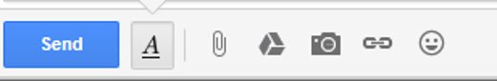

A box should pop-up that will allow you to search for a file you would like to attach.
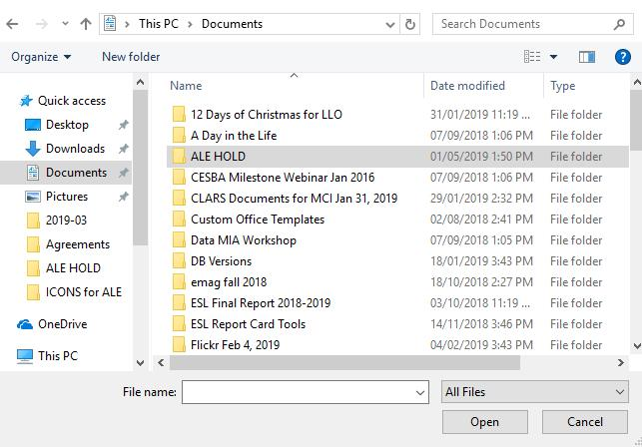
Search for and select the file you wish to attach (left click once to select).
Click “Open”.
The file should now be attached to your email. When you are ready and have double checked everything click “Send”.
Screen reader users should see the buttons for attaching files in the new email form from before. You can use your arrow keys to navigate your list of files and folders, and TAB and SHIFT+TAB to navigate the dialog box. Press enter or space to activate items in this dialog box.

Email Safety Myths and Truths

Myth | Truth
The email says it is from someone I know. So, it must be from someone I know. | An email sender can add any “from” address they want. Spammers use “from” addresses that are forged. They use things that are familiar to you to try and trick you.
If I open an email but do not click any links in the email, I will be safe. | By opening a suspicious email, an attacker can tell your account is active. If you are not 100% sure that an email is safe, you should not open it.

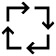Try this/Practice
Send an email to your instructor.

 | Watch these videos to learn more about Gmail basics  Source: GCFGlobal.org | https://www.youtube.com/playlist?list=PL007352170EA6EB06

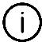Optional: I want to learn more

Complete a full Gmail tutorial here.  Source: GCFGlobal | https://edu.gcfglobal.org/en/gmail/

Complete a full general tutorial here.  Source: GCFGlobal | https://edu.gcfglobal.org/en/email101/

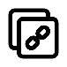Ontario Adult Literacy Curriculum Framework Connection
Competency | Task Groups(s)
Find and Use Information | - Read Continuous Text  - Interpret Documents  - Extract Information from films, broadcasts, and presentations
Communicate Ideas and Information | - Interact with Others  - Complete and Create Documents
Use Digital Technology | - n/a

